Software Eng Shared Doc

As the administrator, I should be able to search for individual members, so that I can perform the necessary action for each user.

As a member I should be able to view my dashboard, so that I can see what benefits I can make use of.

As the administrator, I should be able to search specific events in time like the number of guests we had at the time of an event, so that I can use this data to for future events.

As a user, I want to receive personalized notifications based on my activity and interests, so that I can stay informed about relevant updates.

As a user, I want to block another user, so that they will stop harassing me.

As an administrator, I want to see each users' favourite events and themes, so that we can recommend more of these to the user.

As an administrator, I want to see which memberships are users have so that they can be organised in tiers, most expensive down to free membership.

As an admin, I want to obtain the users email so that I can send them events they are most likely to be interested in.

As a user, I want to be able to reset my password so that I could log into my account if I forgot the password.

Login

As the user, I want to be able to enter the username and password so that I can be authorized into my account

As a developer, I want to be able to retrieve the username and password the user enters so it can be validated and allow the user into their dashboard.

Registration

As a user, I want to be able to create an account so that I can use the apps services.

As a developer, I want to be able to remove the email, username, password values so that I can add these values to the database for future validation.

Membership

As a user, I want to become a member to be involved with the company and its activities

As a developer, I want to be able to retrieve their details so they can be enrolled for a membership.

As a user, I would like me to add in a group with the persons who are doing the same activities.

Benefits

As a user, I want to be able to see a list of the benefits, I have and haven’t used, as a member

As the administrator, I want to be able to ban accounts, so that I can manage any spam activities.

As the user, I want to be able to contact the support team, so I can get help for anything I need.

As a user, I want to see a calendar view of all upcoming events, so that I can easily plan my schedule.

As the admin, I want to be able to manage user’s profiles, so I can resolve any issues the user is experiencing with their profiles.

As the user, I want to be able to post my interests so I can shift and settled into a community/society

As a user, I want to be able to see suggestions made by the website for more ease

As a user, I want to be able to chat with other members in a go-to online member area

Search Capability:

As a user I want to be able to search data such as benefits, company products and memberships to find it quickly.

As a developer I want to be able to make it user-friendly to make the searching efficient and user-friendly so that it saves users time and help them in finding information quickly.

AI & Automation

As a user, I want to have AI-driven content suggestions based on my preferences and activities, so that I can discover new interests.

As an administrator, I want to automate responses to frequently asked questions using a chatbot, so that I can provide instant support to users.

As a user, I would like to have AI based bot that helps me to choose my membership according to my preferences.

Social Media Integration

As a user, I want to share content from the platform on my social media profiles, so that I can engage with my broader social circle.

As an administrator, I want to integrate social media feeds on the platform’s homepage, so that I can showcase live updates and community activities.

Description

|  |  |
| --- | --- |
| Use Case Name | Events |
| Actors | User |
| Flow Events | The user will click on the events button taking them to the area where it will display events, their descriptions, times and dates, locations, durations etc. Here the user can select any event they want and apply to attend. |
| Possible Errors | If a user has already applied to an event, it will display an error message telling them they have already done so.  If an event has maximum attendance (if there is one) the user will be denied attendance. |
| Entry Condition | If a user has put down their attendance for an event |
| Exit Condition | User leaves the events section |

|  |  |
| --- | --- |
| Use Case Name | Benefits |
| Actors | User |
| Flow of events | 1. User clicks on “Benefits”.  2. Benefits page opens.  3. User can choose between un-used and used benefits.  4. User can select “back” to be taken back to the screen to choose again.  5. User can click “Home” to be taken back to home screen. |
| Possible Errors | A user tries to use benefits more than once that are one time use. |
| Entry Condition | Enter the benefit section. |
| Exit Condition | Go back to home screen. |

|  |  |
| --- | --- |
| Use Case Name | Memberships |
| Actor | User |
| Flow of Event | 1.User User clicks on “Membership”.  2.Users select type of membership.  3.User will enter Details.  3. User redirect to events page according to Memberships |
| Possible errors | 1.Enter valid “email or username “  2. Not verified yet  3. Email is already being used |
| Entry Condition | 1. User is on the website and navigates to the membership page.  2.User either logged in or provided necessary details. |
| Exit Condition | Successfully bought membership or cancel between the process |

|  |  |
| --- | --- |
| Use Case Name | Login |
| Actor | User, System, Database |
| Flow of events | 1. User clicks “log-in”.  2. User enters email and password.  3. User gets sent to home page logged in to their account. |
| Possible errors | 2a. User entered incorrect email or password and is asked to re-enter.  2b. Email is not connected to an account, click “Register” to create new account. |
| Entry condition | Click “log-in”. |
| Exit condition | Click “sign-out”. |

|  |  |
| --- | --- |
| Use Case Name | Login |
| Actor | User, Admin, System, Database |
| Flow of events | 1. User selects “Create Account” 2. Sign up page opens 3. Users fills in credentials 4. Presses “Submit” button |
| Possible errors | 1. Character length, “Field must not exceed 50 characters” 2. Error message of “Please enter a valid email” 3. Error message saying the user's password must meet a certain criterion 4. An account with the email could already exist therefore displaying an error message 5. The user may have not entered anything so an error message of “the field is empty” would be displayed |
| Entry condition | The user has an email address and the credentials to sign up |
| Exit condition | The user logs in successfully or the cancels the registration |

|  |  |
| --- | --- |
| Use Case Name | Event attendance search |
| Actor | Admin, System database |
| Flow of events | 1- Goes to event attendance and sees info of the staff  2- search for specific member id and updates on the system |
| Possible errors | Certain number of people are not in the event |
| Entry condition | Click on attendance search button |
| Exit condition | Goto home screen or log out |

|  |  |
| --- | --- |
| Use Case Name | Member search |
| Actor | Admin |
| Flow of events | 1.Click & navigate to Members option  2.Search for the name of member or via Member id |
| Possible errors | 1.Couldn’t Bought membership yet  2. Membership expired  3. Membership type  4. any issue need to sort out  5. |
| Entry condition | 1.Click on member option  2. Admin has access to member search functionality. |
| Exit condition | 1. Admin successfully views the member's details or encounters an error message. |

|  |  |
| --- | --- |
| Use Case Name | User search |
| Actor | Admin, System Database |
| Flow of events | 1. Click on “user search” option.  2. See list of users and relevant information e.g. events attended, date and time of using the space, and emails, and which users are members with their membership type. |
| Possible errors | Shows wrong membership types.  Says some users are members when they arent. |
| Entry condition | Click on “Event attendance” |
| Exit condition | Click “home”. |

Wireframes:

Kai: Membership

Yash: Events

Sam: Benefits, Place Hire, Digital content modules

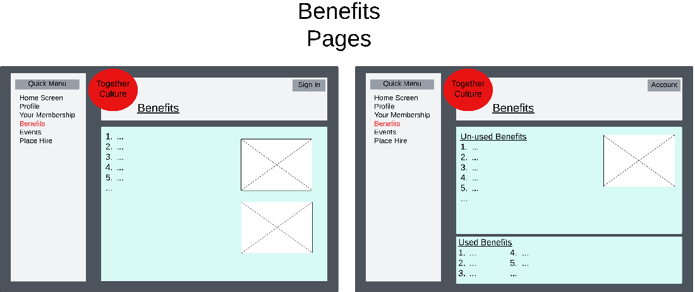

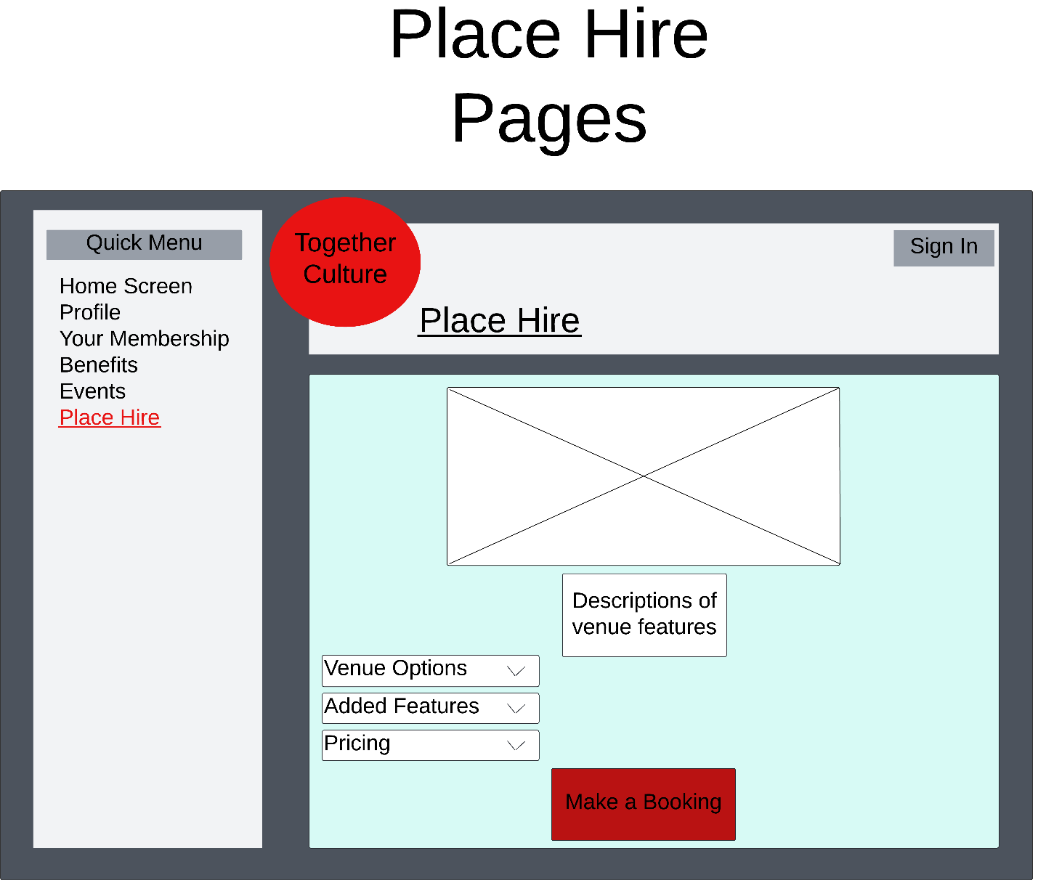

Palwasha: Home screen, login

Sam and Kai: Digital connection board

Sahil: Admin home screen, and log in.